# Flight Booking Application - Project Report

## Table of Contents

1. Flow Diagram
2. Component Details
3. Routing Configuration
4. Route Guards
5. Navigation Flows
6. Validation Logic
7. Services
8. Screenshots

## Flow Diagram

┌─────────────────┐  
│ Login Page │  
│ /login │  
└────────┬────────┘  
 │  
 ├─── Valid Credentials ──────┐  
 │ │  
 └─── Invalid ────> Error │  
 ▼  
 ┌──────────────────┐  
 │ Search Flights │  
 │ /search │  
 └────────┬─────────┘  
 │  
 │ Search Form Submit  
 ▼  
 ┌──────────────────┐  
 │ Flight Results │  
 │ (Same Page) │  
 └────────┬─────────┘  
 │  
 │ Book Flight  
 ▼  
 ┌──────────────────┐  
 │ Booking Success │  
 │ (Alert) │  
 └──────────────────┘  
  
┌─────────────────┐  
│ Register Page │  
│ /register │  
└────────┬────────┘  
 │  
 ├─── Valid Form ──────> Success ──> Redirect to Login  
 │  
 └─── Invalid ──────> Show Errors

## Component Details

### 1. Home Page (Login Component)

**Location:** src/app/components/login/login.component.ts

**Features:** - User authentication form - Email and password validation - Error handling for invalid credentials - Redirect to search page on successful login - Link to registration page

**Validations:** - **Email Field:** - Required - Must be valid email format - Pattern: /^[^\s@]+@[^\s@]+\.[^\s@]+$/

* **Password Field:**
  + Required
  + Minimum length: 6 characters

**Screenshot Placeholders:**

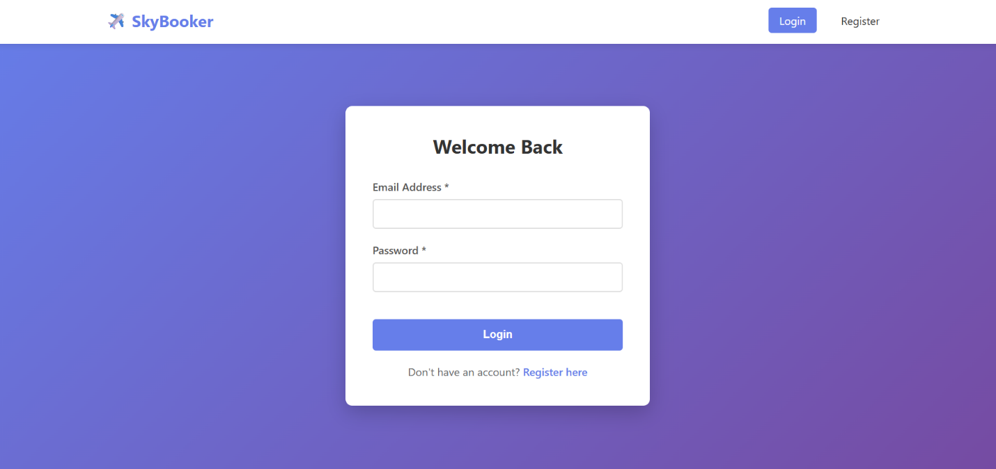

**Validation for Login Form:**

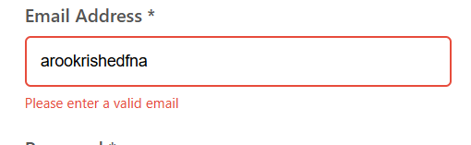

**Login Button Disabled Until Form is Valid:**

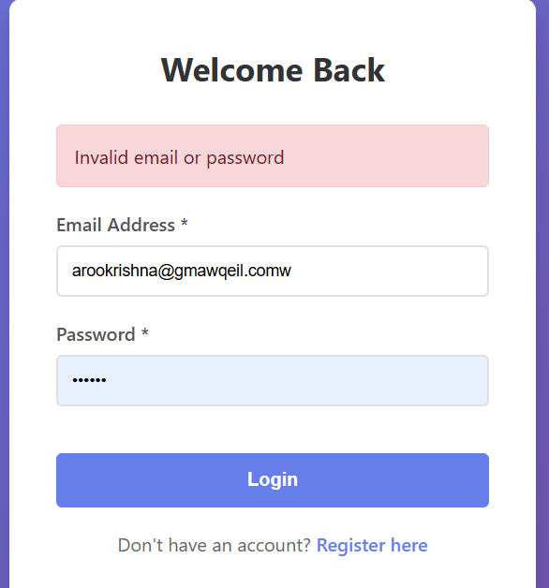

### 2. Sign Up Page (Register Component)

**Location:** src/app/components/register/register.component.ts

**Features:** - User registration form with multiple fields - Comprehensive validation - Password confirmation matching - Redirect to login on successful registration - Duplicate email detection

**Form Fields:** - First Name - Last Name - Email - Phone Number - Password - Confirm Password

**Validations Handled:**

**First Name:** - Required - Minimum 2 characters

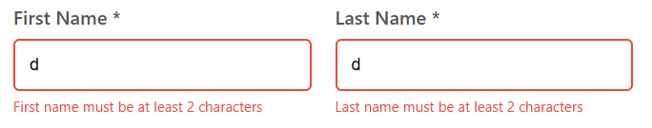**Email:** - Required - Valid email format

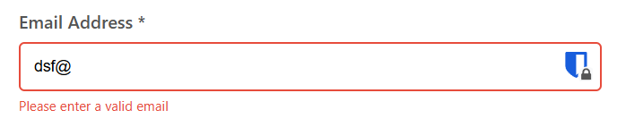**Phone Number:** - Required - Exactly 10 digits - Pattern: /^\d{10}$/

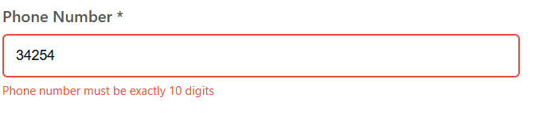**Password:** - Required - Minimum 6 characters

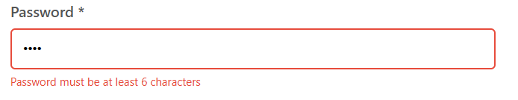**Confirm Password:** - Required - Must match password field

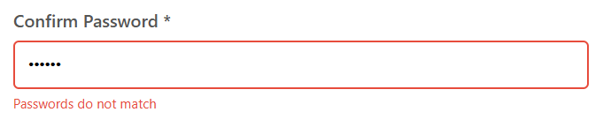**Submit Button Enabled Only After Form is Valid:**

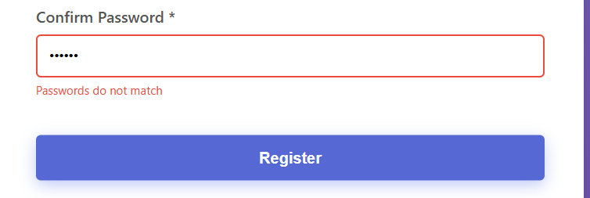**Showing if Email Already Exists:**

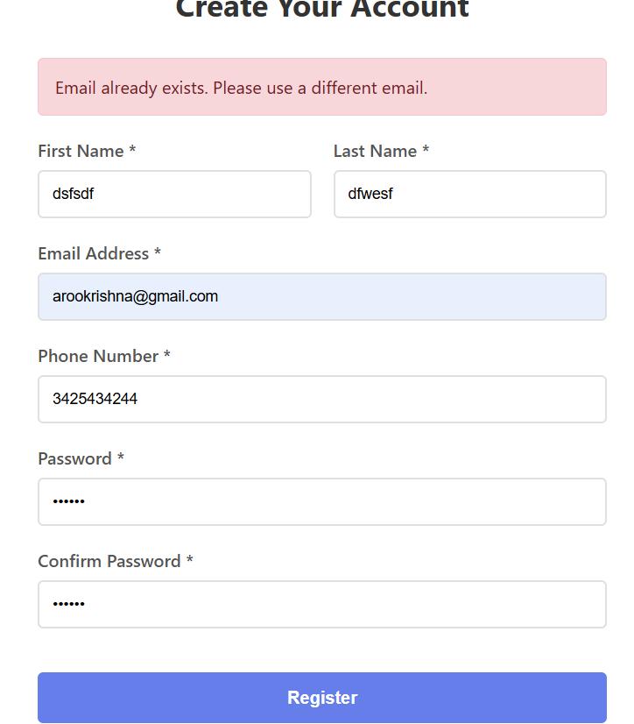

**Book Flight**

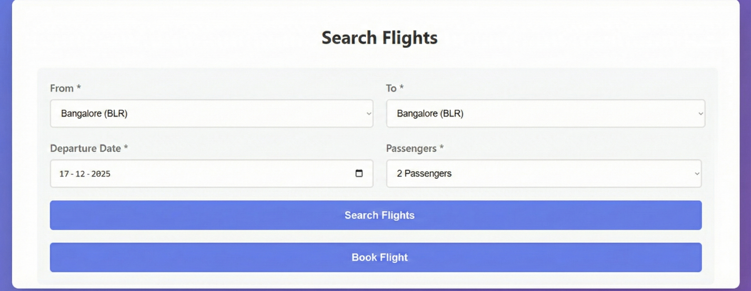

Booked Flights:  
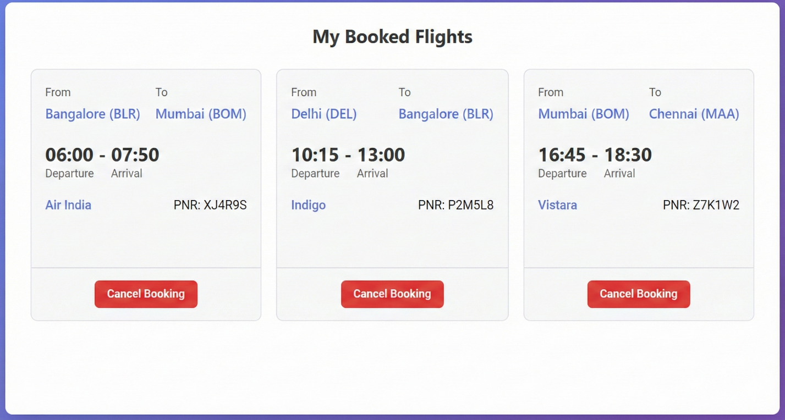  
  
Cancel a Booked flight:



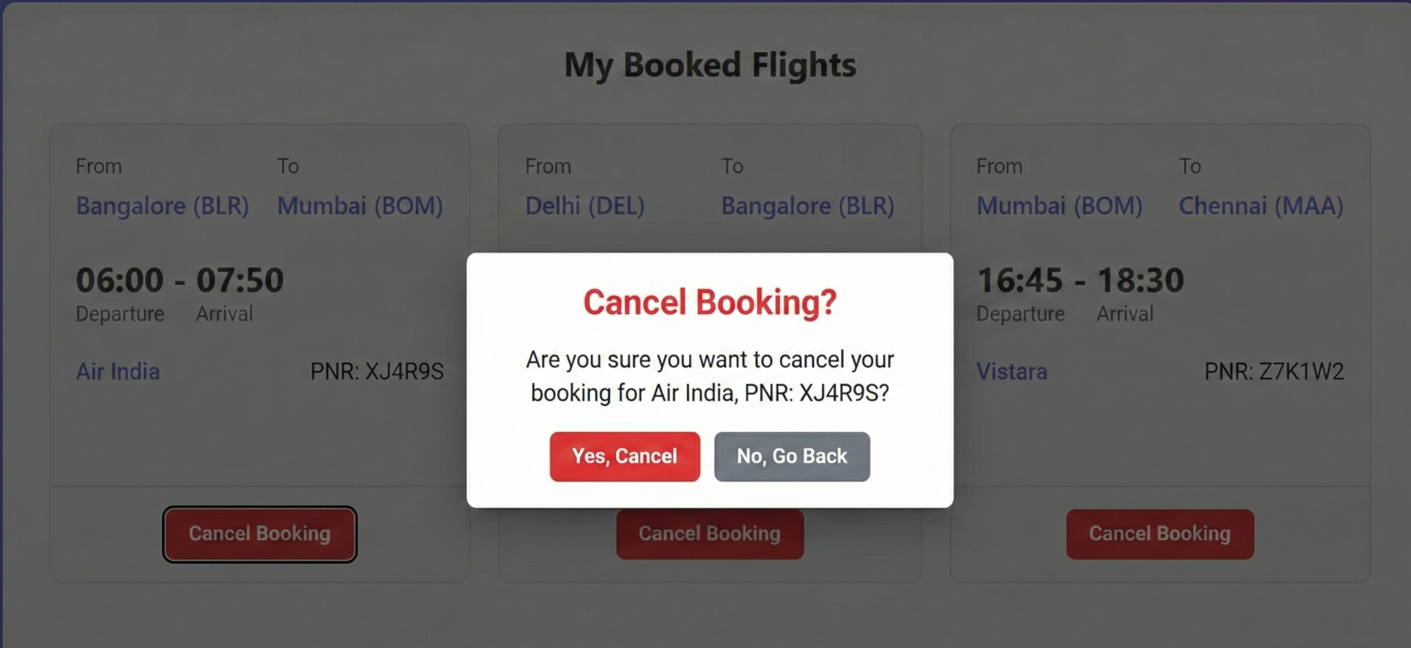

Admin flight panel:  
  
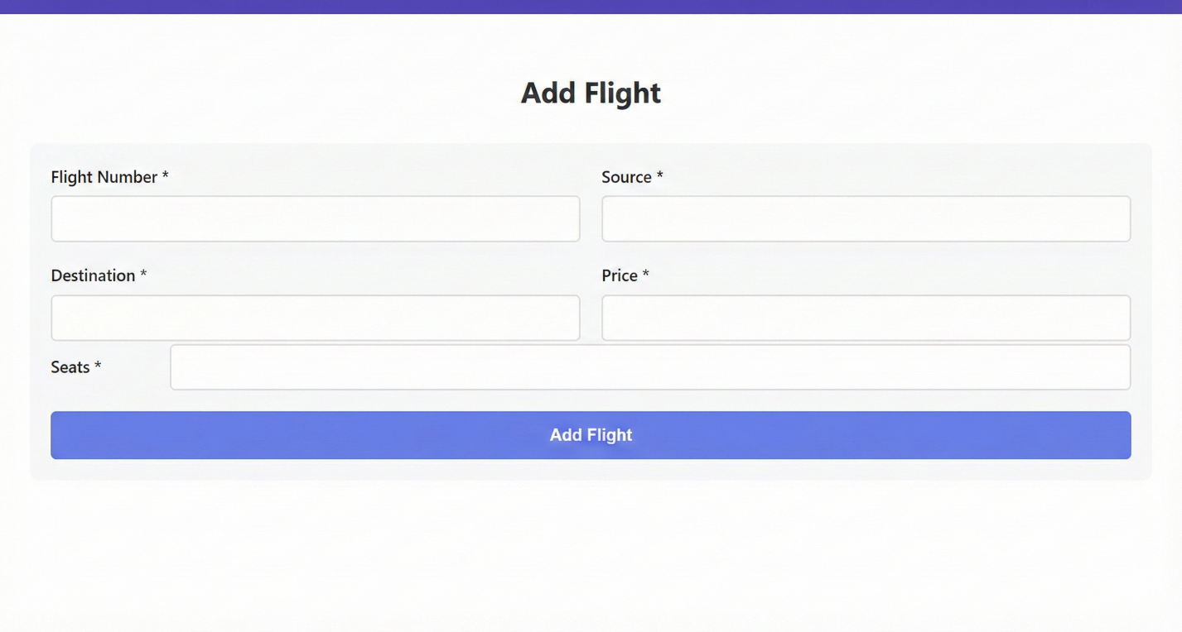  
  
Change password UI:  
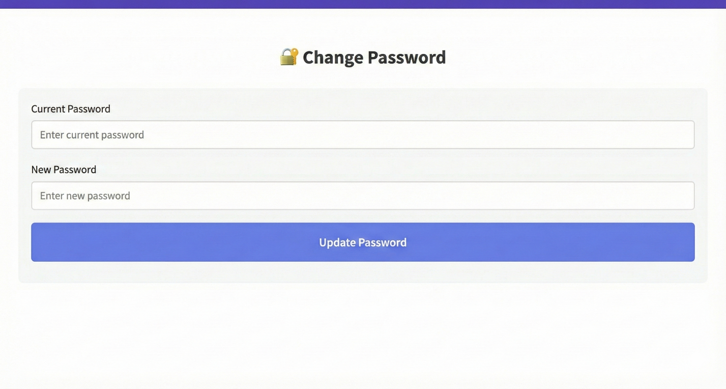

### 3. Search Flights Component

**Location:** src/app/components/search-flights/search-flights.component.ts

**Features:** - Flight search form with filters - Real-time flight search - Display search results - Flight booking functionality - Protected route (requires authentication)

**Form Fields:** - From City (Dropdown) - To City (Dropdown) - Departure Date (Date Picker) - Number of Passengers (Dropdown)

**Available Cities:** - New Delhi (DEL) - Mumbai (BOM) - Bangalore (BLR) - Hyderabad (HYD) - Kolkata (CCU) - Chennai (MAA)

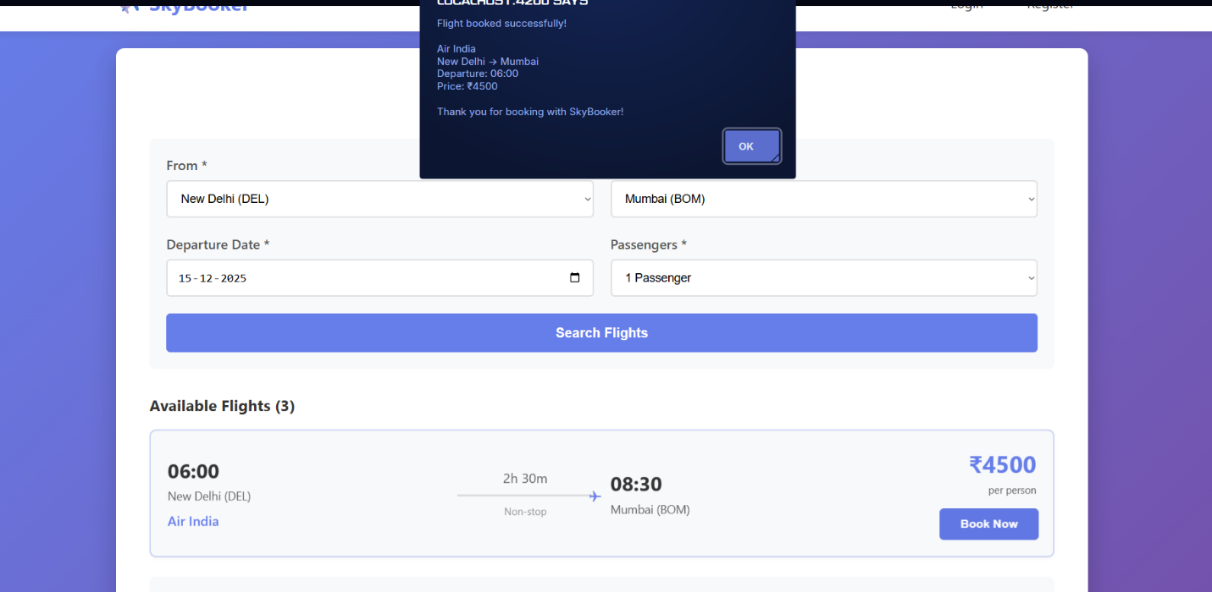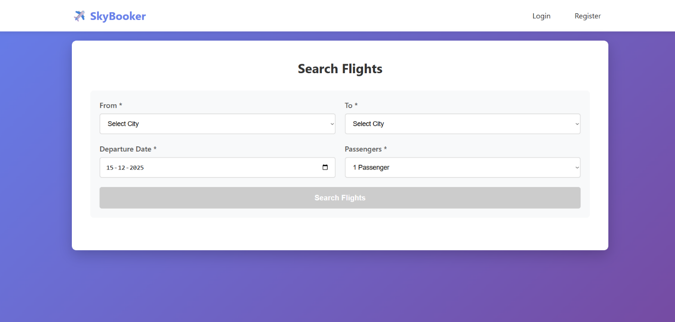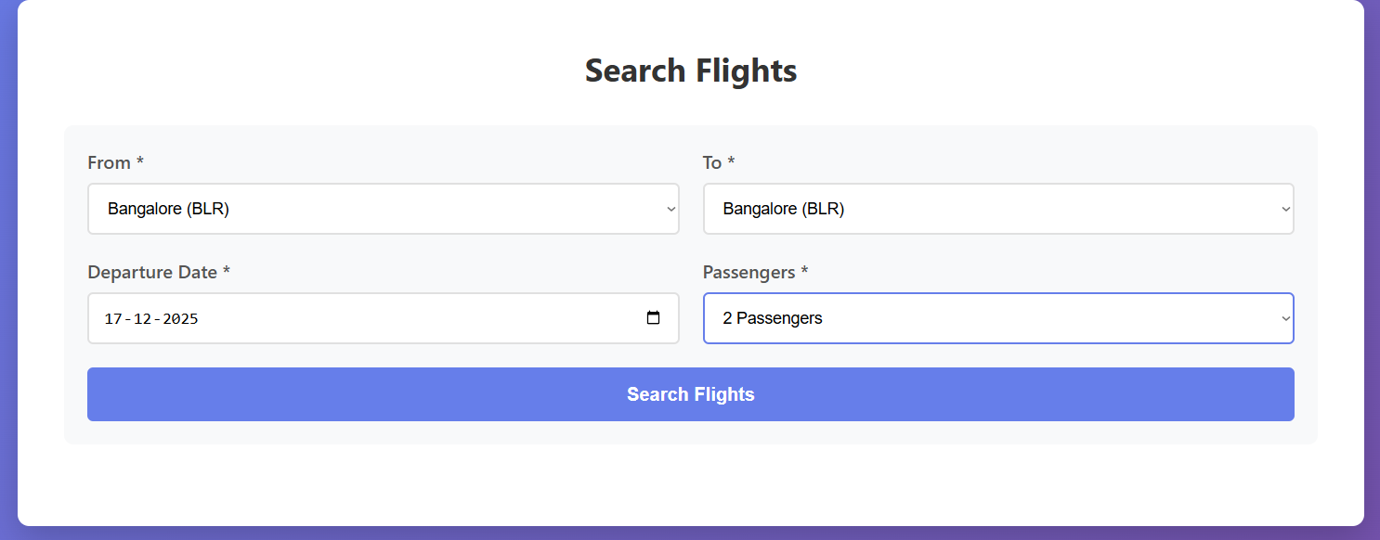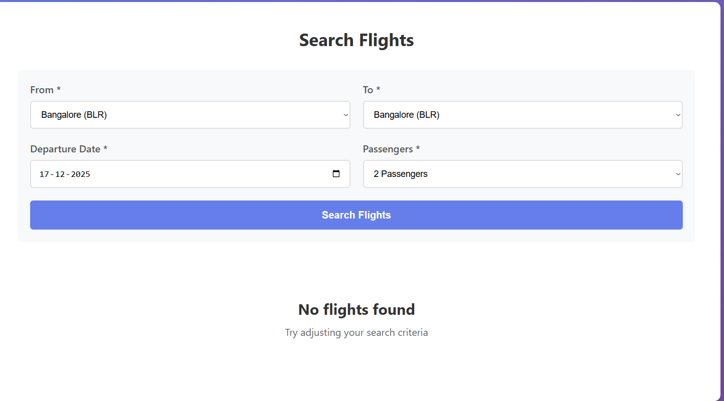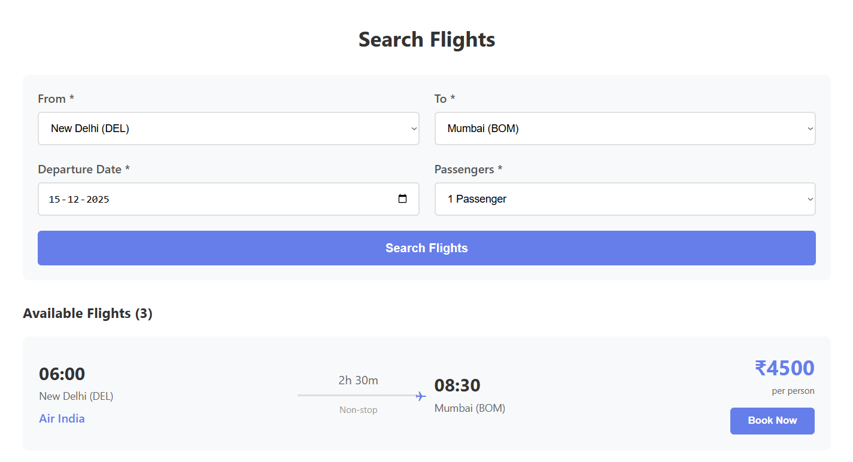

## Routing Configuration

**Location:** src/app/app.routes.ts

### Defined Routes

| Path | Component | Guard | Description |
| --- | --- | --- | --- |
| / | Redirect to /login | None | Default route |
| /login | LoginComponent | None | User login page |
| /register | RegisterComponent | None | User registration page |
| /search | SearchFlightsComponent | AuthGuard | Flight search (protected) |
| ** | Redirect to /login | None | Wildcard for undefined routes |

**Code:**

export const routes: Routes = [  
 { path: '', redirectTo: '/login', pathMatch: 'full' },  
 { path: 'register', component: RegisterComponent },  
 { path: 'login', component: LoginComponent },  
 { path: 'search', component: SearchFlightsComponent, canActivate: [AuthGuard] },  
 { path: '**', redirectTo: '/login' }  
];

## Route Guards

All guards are reactive and depend on the currentUser observable from UserService. Redirections are handled using Angular Router.

### AuthGuard

**Location:** src/app/guards/auth.guard.ts

**Logic:** - Checks if user is logged in through UserService.isLoggedIn() - If authenticated → Allow navigation - If not authenticated → Redirect to /login - Preserves the intended URL in query params for post-login redirect

**Status:** Currently applied to /search route

**Code:**

@Injectable({  
 providedIn: 'root'  
})  
export class AuthGuard implements CanActivate {  
 constructor(  
 private router: Router,  
 private userService: UserService  
 ) {}  
  
 canActivate(route: ActivatedRouteSnapshot, state: RouterStateSnapshot): boolean {  
 if (this.userService.isLoggedIn()) {  
 return true;  
 }  
  
 this.router.navigate(['/login'], { queryParams: { returnUrl: state.url } });  
 return false;  
 }  
}

**Usage:** - Protects /search route - Ensures only authenticated users can search for flights

## Navigation Flows

### Navbar & User State

**Location:** - src/app/app.component.ts - src/app/app.component.html

**Behavior:**

**When No User is Authenticated:** - Displays “Login” button - Displays “Register” button - No logout button visible

[INSERT SCREENSHOT: Navbar - Not logged in state]

**When Authenticated:** - Displays user’s full name (e.g., “👤 John Doe”) - Displays “Logout” button - Shows “Search Flights” link - Hides Login/Register buttons

[INSERT SCREENSHOT: Navbar - Logged in state showing username]

**Changes in Nav Bar After Login:**

[INSERT SCREENSHOT: Before and after login navbar comparison]

**On Logout:** - UserService.logout() is called - User is navigated to /login - Current user state is cleared from localStorage - Navbar reverts to unauthenticated state

[INSERT SCREENSHOT: After logout - navbar changes back]

### Sign Up Flow

**Component:** src/app/components/register/register.component.ts

**Flow:** 1. User fills registration form 2. Form validation occurs in real-time 3. On submit: - Validates all fields - Checks for duplicate email - If successful: - Stores user in localStorage - Shows success message - Redirects to /login after 3 seconds - If email exists: - Shows error message

**On Successful Signup:**

[INSERT SCREENSHOT: Registration success message]

**Sign Up Redirects to Sign In:**

[INSERT SCREENSHOT: Redirect from register to login page]

### Sign In Flow

**Component:** src/app/components/login/login.component.ts

**Flow:** 1. User enters email and password 2. On submit: - Validates credentials against localStorage - If valid: - Sets current user in UserService - Stores user session in localStorage - Redirects to /search - If invalid: - Shows error message: “Invalid email or password”

**On Successful Signin:**

[INSERT SCREENSHOT: Successful login - redirect to search page]

**On Authentication Failure:**

[INSERT SCREENSHOT: Invalid credentials error]

**Sign In Redirects to Search Page:**

[INSERT SCREENSHOT: Automatic redirect after login]

### Search → Flight Search

**Component:** src/app/components/search-flights/search-flights.component.ts

**Flow:** 1. User selects origin and destination cities 2. Selects departure date and number of passengers 3. Clicks “Search Flights” 4. FlightService.searchFlights() is called with search criteria 5. Results are filtered from mock data 6. Flight cards are rendered dynamically

**Submits to:**

FlightService.searchFlights(criteria: FlightSearchCriteria): Observable<Flight[]>

**Results Rendering:** - Uses *ngFor to iterate through flight results - Displays flight cards with all details - Shows “No flights found” if results are empty

[INSERT SCREENSHOT: Search results with multiple flights]

### Booking from Flight List

**Component:** src/app/components/search-flights/search-flights.component.ts

**Flow:** 1. User clicks “Book Now” button on a flight card 2. bookFlight(flight: Flight) method is called 3. Shows confirmation alert with: - Airline name - Route (From → To) - Departure time - Price - Thank you message

**Note:** Authentication is already ensured by the AuthGuard protecting the /search route.

[INSERT SCREENSHOT: Book Now button clicked]

[INSERT SCREENSHOT: Booking confirmation alert]

## Validation Logic

### Custom Validators

#### Email Validator

**Implementation:** Built-in Angular Validators.email

**Rules:** - Must match email pattern: /^[^\s@]+@[^\s@]+\.[^\s@]+$/ - No spaces allowed - Must contain @ symbol - Must have domain extension

**Error Messages:** - “Email is required” - if empty - “Please enter a valid email” - if invalid format

#### Phone Number Validator

**Implementation:** Custom pattern validator

**Rules:** - Must be exactly 10 digits - Pattern: /^\d{10}$/ - No spaces or special characters allowed

**Error Messages:** - “Phone number is required” - if empty - “Phone number must be exactly 10 digits” - if invalid

#### Password Validator

**Implementation:** Built-in Validators.minLength(6)

**Rules:** - Minimum length: 6 characters - Required field

**Error Messages:** - “Password is required” - if empty - “Password must be at least 6 characters” - if too short

#### Password Match Validator

**Implementation:** Custom form-level validator

**Location:** src/app/components/register/register.component.ts

**Code:**

passwordMatchValidator(form: FormGroup) {  
 const password = form.get('password');  
 const confirmPassword = form.get('confirmPassword');  
   
 if (password && confirmPassword && password.value !== confirmPassword.value) {  
 confirmPassword.setErrors({ passwordMismatch: true });  
 return { passwordMismatch: true };  
 }  
 return null;  
}

**Rules:** - Password and Confirm Password must match exactly - Case-sensitive comparison

**Error Messages:** - “Please confirm your password” - if empty - “Passwords do not match” - if mismatch

### Form-Level Validation

#### Register Form

**Component:** src/app/components/register/register.component.ts

**Fields:**

| Field | Validators | Error Conditions |
| --- | --- | --- |
| firstName | required, minLength(2) | Empty or < 2 chars |
| lastName | required, minLength(2) | Empty or < 2 chars |
| email | required, email | Empty or invalid format |
| phone | required, pattern(/^$/) | Empty or not 10 digits |
| password | required, minLength(6) | Empty or < 6 chars |
| confirmPassword | required | Empty or doesn’t match password |

**Form Initialization:**

this.registerForm = this.formBuilder.group({  
 firstName: ['', [Validators.required, Validators.minLength(2)]],  
 lastName: ['', [Validators.required, Validators.minLength(2)]],  
 email: ['', [Validators.required, Validators.email]],  
 phone: ['', [Validators.required, Validators.pattern(/^\d{10}$/)]],  
 password: ['', [Validators.required, Validators.minLength(6)]],  
 confirmPassword: ['', Validators.required]  
}, {  
 validators: this.passwordMatchValidator  
});

#### Login Form

**Component:** src/app/components/login/login.component.ts

**Fields:**

| Field | Validators | Error Conditions |
| --- | --- | --- |
| email | required, email | Empty or invalid format |
| password | required | Empty |

**Form Initialization:**

this.loginForm = this.formBuilder.group({  
 email: ['', [Validators.required, Validators.email]],  
 password: ['', Validators.required]  
});

#### Search Flights Form

**Component:** src/app/components/search-flights/search-flights.component.ts

**Fields:**

| Field | Validators | Error Conditions |
| --- | --- | --- |
| from | required | Not selected |
| to | required | Not selected |
| date | required | Not selected |
| passengers | required | Not selected (default: 1) |

**Form Initialization:**

this.searchForm = this.formBuilder.group({  
 from: ['', Validators.required],  
 to: ['', Validators.required],  
 date: ['', Validators.required],  
 passengers: [1, Validators.required]  
});

**Date Validation:** - Minimum date is set to today’s date - Implemented using HTML5 date input min attribute

const today = new Date().toISOString().split('T')[0];  
document.getElementById('departDate').setAttribute('min', today);

## Services

### UserService Integration

**Location:** src/app/services/user.service.ts

#### Core Responsibilities

**1. User State Management:**

private currentUserSubject: BehaviorSubject<User | null>;  
public currentUser: Observable<User | null>;

* Uses RxJS BehaviorSubject for reactive state management
* Initialized from localStorage on service construction
* Observable allows components to subscribe to user state changes

**2. Authentication Methods:**

**register(user: User): boolean** - Validates if email already exists - Assigns unique ID using Date.now() - Stores user array in localStorage - Returns true if successful, false if duplicate email

**login(email: string, password: string): User | null** - Searches users array for matching credentials - If found: - Updates currentUserSubject - Stores current user in localStorage - Returns user object - If not found: - Returns null

**logout(): void** - Clears current user from localStorage - Resets currentUserSubject to null - Triggers subscribers to update UI

**isLoggedIn(): boolean** - Returns true if currentUserValue is not null - Used by AuthGuard for route protection

**3. Data Persistence:** - All user data stored in browser’s localStorage - Key: 'users' - array of all registered users - Key: 'currentUser' - currently authenticated user - Data persists across browser sessions

### FlightService Integration

**Location:** src/app/services/flight.service.ts

#### Core Responsibilities

**1. Mock Flight Data:**

private mockFlights: Flight[] = [  
 // 10 pre-defined flight objects  
];

* Contains 10 mock flights covering various routes
* Each flight includes:
  + Airline name
  + Origin and destination (code and full name)
  + Departure and arrival times
  + Duration
  + Price in INR (₹)

**2. Search Functionality:**

**searchFlights(criteria: FlightSearchCriteria): Observable<Flight[]>** - Filters mock flights based on origin and destination - Returns Observable for reactive programming - Criteria includes: - from: string (airport code) - to: string (airport code) - date: string (departure date) - passengers: number

**Implementation:**

searchFlights(criteria: FlightSearchCriteria): Observable<Flight[]> {  
 const results = this.mockFlights.filter(  
 flight => flight.from === criteria.from && flight.to === criteria.to  
 );  
 return of(results);  
}

**3. Flight Retrieval:**

**getFlightById(id: number): Flight | undefined** - Retrieves single flight by ID - Used for booking confirmation - Returns undefined if not found

## Technology Stack

### Frontend Framework

* **Angular 18+** (Standalone Components)
* **TypeScript** for type safety
* **RxJS** for reactive programming

### UI/Styling

* **Custom CSS** with modern design
* **Responsive Grid Layout**
* **CSS Animations** and transitions
* **Gradient backgrounds**
* **Box shadows** and hover effects

### Form Management

* **Reactive Forms** (FormBuilder, FormGroup)
* **Built-in Validators**
* **Custom Validators**
* **Real-time validation feedback**

### Routing

* **Angular Router**
* **Route Guards** (CanActivate)
* **Lazy Loading** ready structure
* **Query Parameters** for return URLs

### State Management

* **Services** with dependency injection
* **RxJS BehaviorSubject** for reactive state
* **LocalStorage** for persistence

## Key Features Implemented

✅ **Component-Based Architecture** - 3 main components (Login, Register, Search Flights) - Reusable and maintainable code structure - Standalone components (Angular 18+)

✅ **Angular Routing** - Multiple routes with navigation - Protected routes using guards - Automatic redirects

✅ **Form Handling & Validation** - Reactive forms with FormBuilder - Multiple validation types - Real-time error display - Custom validators

✅ **User Authentication** - Registration with duplicate detection - Login with credential validation - Session management - Logout functionality

✅ **Flight Search & Booking** - Dynamic search with filters - Mock data integration - Result display with animations - Booking confirmation

✅ **Responsive Design** - Mobile-friendly layouts - Tablet support - Desktop optimized - Flexible grid system

✅ **Clean UI/UX** - Modern gradient design - Smooth animations - Hover effects - Loading states - Error feedback

## Project Structure

src/  
├── app/  
│ ├── components/  
│ │ ├── login/  
│ │ │ ├── login.component.ts  
│ │ │ ├── login.component.html  
│ │ │ └── login.component.css  
│ │ ├── register/  
│ │ │ ├── register.component.ts  
│ │ │ ├── register.component.html  
│ │ │ └── register.component.css  
│ │ └── search-flights/  
│ │ ├── search-flights.component.ts  
│ │ ├── search-flights.component.html  
│ │ └── search-flights.component.css  
│ ├── services/  
│ │ ├── user.service.ts  
│ │ └── flight.service.ts  
│ ├── models/  
│ │ ├── user.model.ts  
│ │ └── flight.model.ts  
│ ├── guards/  
│ │ └── auth.guard.ts  
│ ├── app.component.ts  
│ ├── app.component.html  
│ ├── app.component.css  
│ ├── app.routes.ts  
│ └── app.config.ts  
├── main.ts  
├── index.html  
└── styles.css

## Testing Instructions

### To Run the Application:

1. **Install Dependencies:**

* npm install

1. **Start Development Server:**

* ng serve

1. **Access Application:**
   * Open browser to http://localhost:4200

### Test Scenarios:

1. **Registration:**
   * Try registering with invalid email → Should show error
   * Try registering with short password → Should show error
   * Try registering with mismatched passwords → Should show error
   * Register successfully → Should redirect to login
2. **Login:**
   * Try logging in without registration → Should show error
   * Try with wrong password → Should show error
   * Login successfully → Should redirect to search page
3. **Flight Search:**
   * Try accessing /search without login → Should redirect to login
   * Try searching with empty fields → Button should be disabled
   * Search for available route → Should show flights
   * Search for unavailable route → Should show “No flights found”
4. **Booking:**
   * Click “Book Now” → Should show confirmation alert
   * Verify flight details in alert
5. **Logout:**
   * Click logout → Should redirect to login page
   * Try accessing /search → Should redirect to login

## Conclusion

This Flight Booking Application demonstrates: - Modern Angular development practices - Component-based architecture - Reactive forms with comprehensive validation - Route protection and navigation - State management with services - Clean, responsive UI design - User authentication flow - Mock data handling

The application is fully functional and ready for further enhancement with backend integration.

## Screenshots Section

**Note:** Replace all [INSERT SCREENSHOT: ...] placeholders with actual screenshots from your running application.

### How to Capture Screenshots:

1. Run the application: ng serve
2. Open in browser: http://localhost:4200
3. Navigate through each flow
4. Capture screenshots using:
   * Windows: Windows + Shift + S
   * Mac: Command + Shift + 4
   * Browser DevTools: Ctrl + Shift + P → “Screenshot”

### Required Screenshots Checklist:

#### Login Page:

* ☐ Empty login form
* ☐ Email validation error
* ☐ Password validation error
* ☐ Disabled login button
* ☐ Invalid credentials error

#### Register Page:

* ☐ Empty registration form
* ☐ First name validation
* ☐ Last name validation
* ☐ Email validation
* ☐ Phone validation
* ☐ Password validation
* ☐ Password mismatch error
* ☐ Disabled submit button
* ☐ Duplicate email error
* ☐ Success message

#### Search Flights:

* ☐ Empty search form
* ☐ Form validation errors
* ☐ Disabled search button
* ☐ Loading state
* ☐ No flights found
* ☐ Flight results display
* ☐ Individual flight card
* ☐ Hover effects
* ☐ Booking confirmation

#### Navigation:

* ☐ Navbar - logged out
* ☐ Navbar - logged in
* ☐ Logout confirmation